SPRING 2020 C.I.S 4900/4905 Page 10

DEPARTMENT OF COMPUTER & INFORMATION SCIENCE BROOKLYN COLLEGE

SUPERVISOR INTERIM REPORT

The following is to be completed by the student:

Name :

Course

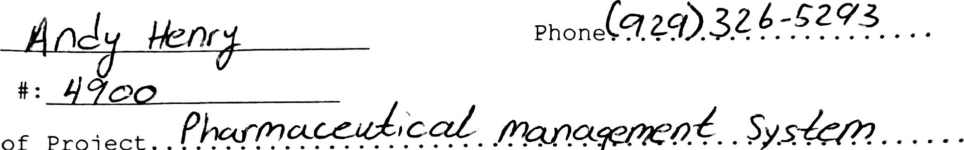

man.yrra.(..

Title of Project.

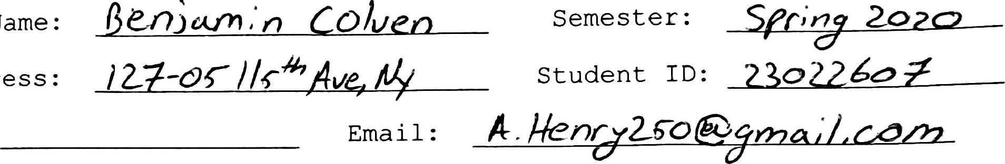Supervisor Name: Address :

Phone :

DO NOT WRITE BELOW THIS LINE

To the supervisor: Thank you for supervising a student proj ect for the Department of Computer & Information Science . Your frank evaluation and answers to the questions will help us in assessing the student's progress. Please complete this form and mail by Mar 12 to:

Mailbox, CIS 4900/4905 Program

Department of Computer & Information Science

Brooklyn College

2900 Bedford Avenue

Brooklyn, N.Y. 11210

1. Are you satisfied with the student's progress?
2. On a scale of 0 to 10, how would you rate his or her work to date?
3. Do you believe that the student will be able to complete the project on time? If not, could you indicate why.
4. Please feel free to make any comments on the progress of the student (use reverse side if necessary) .